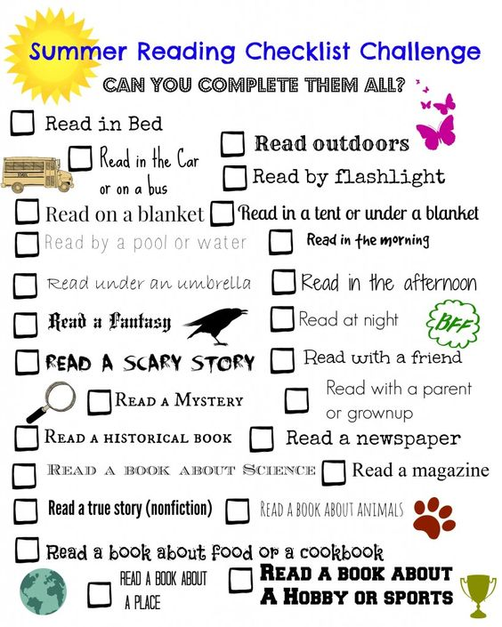

Madison Valley Public Library 20 minutes a day

Complete by August 15, bring it in to claim a prize, enter to win a Kindle Fire!